e-Government in Israel

The Five Layers Model
of
e-Government

Ministry of Finance
General Accountant Office
September 2002

Prepared by:
Boaz Chen and David Rashty
Addwise Informanage Ltd.

TABLE OF CONTENTS

PREFACE 3
e-GOVERNMENT – DEFINITION AND SERVICE LEVELS 3
Various levels of e-Government 3
GOVERMENTAL DOING IN E-GOVERNMENT 4
Five Layers Model 4
LAYER 1 – INTER-GOVERNMENTAL COMMUNICATION INFRASTRUCTURE 6
The Vision 6
Offices Infrastructure 7
Gov.net – The Governmental Internet 7
LAYER 2 – HORIZONTAL APPLICATIONS 7
“Merkava” project - Governmental ERP 7
LAYER 3 – INFRASTRUCTURE FOR THE CITIZEN 9
“Tehila” Project – Governmental Infrastructure for the Internet Age 9
“Tamar” – Public Key Infrastructure 10
LAYER 4 – CITIZEN-SERVICE APPLICATIONS 11
Governmental Payment Service (“Shoham”) 11
Government Gate 13
The Safe 14
Government Forms Service 14
LAYER 5 – SUPPORT AND ASSIMILATION 15
“Lehava” Project 15
SUMMARY 17
BIBLIOGRAPHY 19
References 19
Additional Resources 19

PREFACE

“e-Government” is a modern term, though actually it is a continuation of a many years’ process.

Various governments around the world, including the one in Israel, have tried in the past to improve the quality of service to the citizen on one hand, while reducing the expenses involved, on the other hand. These two goals seem to contradict one another.
Various solutions were developed starting from mail, telephone and fax, through usage of mass media instruments to automatic self service stations.

The development of the Internet brought with it a significant push towards e-Government. The Internet was the first to unify various capabilities on a single infrastructure, creating a variety of new communication methods: published information to the masses (web sites), multi-participants communication (forums) or one-on–one (e-mail), synchronous communication (chat) and asynchronous one, and the ability to perform activities in real-time (interactivity).

In May 2002, the government of Israel decided to realize the e-government project. This document reviews the five layers model of e-government – a model that was created by the General Accountant in the Ministry of Finance, and presents the initial foundation to promote initiatives in the area of e-Government in Israel.

e-GOVERNMENT – DEFINITION AND SERVICE LEVELS

There is no one definition for “e-Government”. The term was first presented in a report made by the sub committee of information technology, in the 1997 Knesset, as the name for a new policy in Israeli public service: “The new policy will be called “ e-Government”, which means, in the contents of the information revolution, leveraging the information technology to improve and strengthen the mutual connection between the public and the government”.

“e-Government” is the government version to the term “e-Business”, developed in the last decade. A short but general definition to the term is: “using technology to fulfill government roles”. A more accurate and realistic definition would be:

Providing governmental information and services, using technology as the communication channel to the citizen

This does not include computerization and technology projects that only serve internal government bodies.

Various levels of e-Government

e-Government is an abstract term, that may be realized in many different ways. There are several methods to evaluate e-Government; most of them are based on a phase-forwarding model. A common model, based on a developing process of a fully on-line government, includes 5 phases²:
First phase – Publishing governmental information by the government.
Second phase – Communicating with the citizen via e-mail and other electronic instruments.
Third phase – Providing ways to perform official activities.
Forth phase – Personalization of services.
Fifth phase – Complete organizational change, enabling a fully on-lined service provision and performance of transactions.

Recently, in a report reviewing the status of e-Government in the world³, the UN used a similar scale, trying to be more general (to fit less developed countries). In this scale there are five phases of e-Government as well:
- Emerging – Existence of several static governmental sites with limited information.
- Enhanced – Content and information are updated in an on-going way, including dynamic information.
- Interactive – Downloading forms and contacting governmental bodies (e-mail and web).
- Transactional – Ability to perform on-line payments.
- Seamless – Full integration of all governmental services on the Internet¹.

Evaluation from a user perspective requires the evaluation of every single service. The basic need of the average citizen (as opposed to researchers, reporters etc.), is to be able to perform a certain activity with the government. The e-Government system can address this need in the following levels:

- Initial information – Opening times, things to bring, service centers, previous conditions, forms samples (not to fill) etc. – this information may prevent mistakes, long waits for answers and useless travels to the service centers.
- Non on-line service – Forms to fill and send, e-mail for on-line approach and any mean that will enable the citizen to perform as many activities without coming to the service center – in this case the technology acts as the mediator between the citizen and the authority. Though this service is usually slower than the one in the service center, it saves the citizen the need to travel to the service center and to depend on limited opening times.
- On-line service – Providing the entire service on-line – technology replaces the man in performing the actions, allowing self-service and immediate reply.

GOVERMENTAL DOING IN E-GOVERNMENT

Five Layers Model

The computer unit in the General accountant office, headed by Mr. Itzhak Cohen, is working for 6 years now on forwarding the e-Government project. The actual activity in this area began at the start of 1997, with the nomination of the governmental Internet committee and the initiation of “Tehila” project. Along the way many projects and initiations were added. Toward 2002 the master plan was created and a government decision was passed, to significantly forward and allocate resources for the e-government services.

The master plan is based on the advanced e-Government model, developed in the General accountant computer unit. This model is used to forward the many initiations on the way to achieve the e-Government vision. This model is called: “The five layers model” and relates to all the layers that need to be addressed in order to realize the vision. The five layers model divides the e-Government layout technologically, and describes the entire systems required for the realization of a full e-Government vision.

The layers are laid horizontally. Each layer deals with a certain depth level along the line of communication between the citizen and the government.

The citizen is at the head of the pyramid. As lower the level is - so it contains a more infrastructure technologies. In spite their relative distance from the end-user, they are the ones allowing the required functionality.

Naturally there is no need for the full layout in order to provide the basic levels of e-Government, such as general information site on the Internet. The aspiration for a seamless government, a fundamental organizational restructuring and a full and convenient service to the citizen, require parallel handling in all five levels. The five levels from bottom to top are:

- Layer 1 – Inter-governmental communication infrastructure: The basis of the government ability to take care of the citizen is the existence of an intern-governmental communication infrastructure, that will allow information flow within the government and will give the different governmental bodies the ability to provide service under the same umbrella. Without such infrastructure, each office is forced to work independently, and the level of service is directly damaged. Both for the lack of unity as well as for the fact that not all offices will forward e-Government in the desired pace.
- Layer 2 – Inter-governmental applications: An inter-governmental layer of horizontal applications and databases in the government. This is the governmental ERP, covering a variety of subjects, which are in the heart of the organization: budget, logistics, manpower etc. The integration of the systems enables a unified terminology and accessibility needed to reach full integration of the services.
- Layer 3 – Application secured infrastructure: This layer includes communication-infrastructure as well as technologies that allow for certain governmental-systems transparency, while maintaining information security, in order to communicate with the citizen. The existence of layers 1 and 2 enables usage of an all-governmental, unified infrastructure for communication with the citizen.
- Layer 4 – Services Infrastructure: This layer includes the layout of e-Government applications, through which the citizen can view interactive sites and perform ctivities. These applications a especially built for public service and are adjusted to its needs.
- Layer 5 – Support and Assimilation: A layer that consists physical technologies and resources required for education and assimilation of the technology in challenged populations. This Layer is responsible for closing the digital gap and the actual usage of the systems by the common citizen.

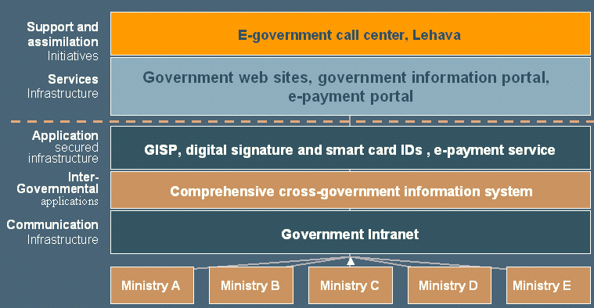

LAYER 1 – INTER-GOVERNMENTAL COMMUNICATION INFRASTRUCTURE

The Vision

We can view e-Government as a collection of independent services, provided by the various governmental bodies. Out of that we can assume that it is possible to give quality e-Government service without a full intern-governmental communication. In reality this possibility does not exist for a number of reasons:
- Realization ability – The need for each body to establish and maintain an advanced technological layout for service cannot be realized from reasons of budget, knowledge and manpower. In addition to the big waste of resources that will be caused, the probability that small governmental bodies will be able to achieve it, is small.
- Dispersion of Information – The governmental information is spread between the different government systems. A basic requirement in a quality citizen service is to enable centralized performance of tasks. Change of address, for example, will not be considered easy-to-use if there is a need to perform it in several offices separately, or if updated from one office to another only once a week.
- Education and citizen care - In order to provide an on-line government service, it is not enough to maintain a technological system. The clerks’ system has to support public queries, and adjust the way of handling to the modern work pace. A citizen that faces difficulties with on-line payment expects to receive reply on his e-mail in a short time. If government clerks will not be able to pass the query details between them and to contact the citizen via e-mail, the e-Government will be stuck in the old-world bureaucracy. Moreover, for the clerks to be aware of habits and needs of on-line users, they need to know and use the technology themselves.

From these reasons in their entirety it is apparent that a real e-Government requires a broad communication infrastructure, covering the entire governmental factors – both between the government systems as well as among the government employees themselves.

Offices Infrastructure

The existing infrastructure in the various government offices was developed gradually and separately for each office. Even today there are significant differences between the various offices inter-communication level, and between different sites of the same office. In all governmental bodies today, there is an internal network based on TCP/IP, and in half of them there is internal usage of e-mail. In addition there are several designated horizontal networks, established for horizontal systems such as the network connecting the accountant units, the network serving the financial budget management system and the network connecting to the personnel system in the state’s public service.

There is no proper connection between the various offices networks. E-mail, for example, goes through external mail servers and thus cannot be used for classified material.

Gov.net – The Governmental Intranet

The governmental Intranet is an innovative project initiated to create a secure communication infrastructure between government offices. This project was initiated by the ministry of Finance and is funded by it. This project is a continuation of the successful “Tehila” project.

The purpose of the project is to connect all the government offices’ networks to allow passing of classifies information among them (specifically e-mail) and create a central site for centralized services and applications.
The new network is created as an exchange to which the offices networks can be connected in a way that will not compromise their existing security level. Meaning: the ability to move from one network to another will be blocked (as much as possible), and an intruder that will succeed in entering a single governmental network, will not be able to use it as a bridge to enter a more secured network. In time, the Gov.net will replace the external connectivity that exists between the offices, endangering the security of the intern-offices network.

The characterization of the process was finalized at the beginning of 2002, and the network is under a pilot preparation process. The goal is to finalize the pilot by the end of 2002 and apply the network during 2003.

LAYER 2 – Inter-Governmental Applications

The Inter-Governmental applications layer consists of applications that serve the entire governmental apparatus. These applications create the foundation to an e-Government both in improving the inter-governmental work (thus improving citizen service) as well as acting as a basis to open unified and united services to the public.

“Merkava” project - Governmental ERP

The huge gap between the need for governmental ERP systems and the lack of them brought the ministry of Finance to initiate this project. “Merkava” is the most significant governmental computerized project in the history of the state of Israel, and is aimed to form the face of computerized governmental offices in the next decade.

“Merkava” project represents the frame plan, aimed to bring improvement of service to the citizen and in government activities quality, through improvement of work processes and the computerized infrastructures serving it. The project answers the horizontal demands of systems, today operated by different governmental units, through integration with the designated systems of each office. The first subjects that will be addressed in the first phase of the project will be finance, human resources and logistics management as well as managerial systems of the Israeli police and public housing. These applications are lead and managed by the state’s public service, the Israeli police and various bodies in the ministry of Finance.
“Ofan” project is the first of “Merkava” initiated to penetrate the general organizational computerization. This project offers government offices with brand new systems for managing finance, manpower, logistics and assets. The systems are of functional-wealth, information-wealth, availability and quality. The offices participating in this project will gain a significant increase in inter-office functional ability and resource savings.

The objectives defined for the project are:
- Setting correlated and efficient policy.
- Correlation and synchronization among offices, creating cooperation between offices and units that did not cooperate in the past.
- Allowing offices to concentrate on designated work processes.
- Information transparency between offices.
- Reduced operation costs in all governmental offices.
- Good integration ability with new technologies.

The contribution of the project can be described as follows:

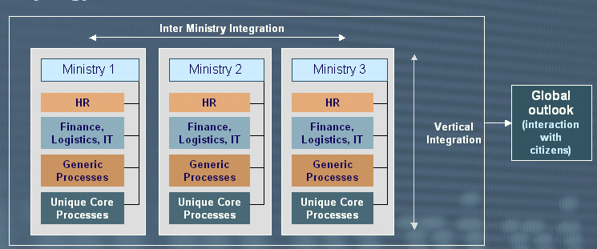

A unified infrastructure will enable each office to achieve better integration between different areas that were computerized separately and without unification. This will allow better management of the office, better adjustment ability to changes and improved capabilities of offering centralized open information to the public. None of the offices possessed the ability to create such unification on its own resources.

The use of a single infrastructure by all the offices allows cost reduction in the different systems management. Furthermore, it allows information integration, cooperation in terminology and ability to provide horizontal service.

The project is being set up these days, following a large tender out of which the technological infrastructure of SAP was selected. Not like previous projects, it was decided to minimize the changes in the product, and as the Deputy General Accountant responsible for the project said: “it will be the first time that the organization adjusts itself to the system and not vice versa”.
This strategy allows a very quick set up of the system using the product’s existing modules. The Ministry of culture, science and sports as well and the Ministry of Finance were chosen as pilot sites for the project.
180 people are involved in the project today, and the target is to increase the “Ofan” services in the pilot until August 2003. The full-scale project that will include the entire governmental offices will continue until 2007.

LAYER 3 – Application Secured Infrastructure

This layer consists of a technological and human-operational layout creating connectivity between the government systems’ apparatus and the citizen. Needless to say that without such infrastructure and an on-going quality operation of it, there will be no guarantee of an available, accessible and highly authentic service.

“Tehila” Project – Governmental Secured Infrastructure for the Internet Age

The “Tehila” project was established in 1997. The designation of the project is to provide the various offices with three primary services:
- Providing government users with high security access to the Internet services from their individual workstations. Until “Tehila” was set up, government workers’ connectivity to the Internet involved technological complicity and high costs. The solutions varied from an Internet station in the library, through providing 2 computers to an entitled employee, and up to a connection that was against policy and jeopardizing the office network information security (and of the entire governmental network).
- Hosting government sites that will provide information and services to the public, in a secured “server farm”. Information security devices will protect the data. Until “Tehila” was set up, the sites were hosted by private ISPs, at a very low security level. Some of them were actually breached.
- Providing the infrastructure to support the “digital ID” project, granting citizens with a secured, digital identification method to deal with governmental bodies and other (“Telem” project).

The primary motive for the farm set up was the need to protect governmental databases in the Internet and prevent cyber-terror attacks. “Tehila” project allows its visitors to be a part of the e-Government revolution, while maintaining maximum-security level.

In “Tehila” an exclusive, proprietary software is applied, which provides protection against penetration attempts, preventing them in real-time. Some 70% of the government offices are hosted in “Tehila” today, and none of them was breached or violated till now.
“Tehila” deals today with connecting the inter-offices databases to the Internet in a secured way, using advanced security technologies and local developments.
The bandwidth of “Tehila” connection to the Internet grew from 2 Mega in 2000 to 16 Mega in 2002.

“Tehila” already allows government workers to surf the Internet from their individual workstations and to use e-mail.

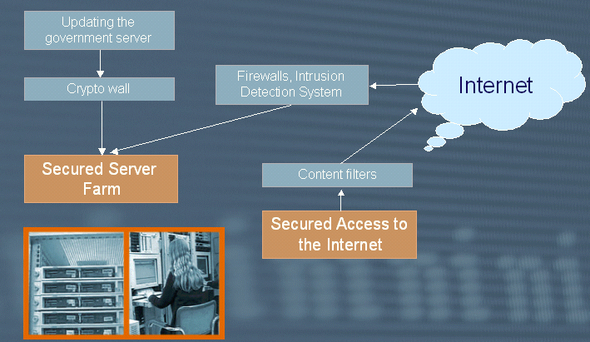
An illustration describing “Tehila” project

“Tamar” – Public Key Infrastructure

The “Tamar” project was made to allow citizens and government workers to receive services and perform activities with government offices in a secure, efficient, sophisticated and convenient way. The project includes the following parts:
- An identity certification based on smart card and electronic signature to every citizen (Telem) – starting mid 2003 – every Israeli citizen will have a digital identity card, that will be used both for digital signature as well as to identify himself when receiving on-line personal information.
- Government Worker certificate based on smart card and electronic signature to all government employees (“Tamuz”).
- Smart card-based certificate to business owners.
- Official forms service that includes electronic signature – by the end of 2002, 50 forms will be prepared that will allow electronic signature and direct sending to the appropriate systems.

 | 

Digital identity cards samples

All the citizens will receive a smart identity card by 2006 – 40% of the house holds will receive home input devices for the ID cards.

LAYER 4 – Services Infrastructure

Governmental Payment Service (“Shoham”)

The Governmental payment service is an innovative initiative of the Ministry of Finance’s information systems unit, and is the first step on the Israeli government’s way to electronic commerce, aimed to continue improving the service to the citizen.

The service is, in fact, an electronic commerce system, allowing every governmental establishment to manage a virtual store on the network, without the need to deal with collection apparatus or security. This way, governmental establishments can offer the public paid on-line services, products and collection of bonds and taxes via the Internet, without bureaucracy.

The existing services are divided to several categories:
- Taxes and fines payments.
- Digital products purchase (certificates, files, paid access to databases).
- Payment for products such as governmental publications.

More than 20 virtual stores of government offices and establishments are active today, and by the end of 2002, this number will be duplicated.

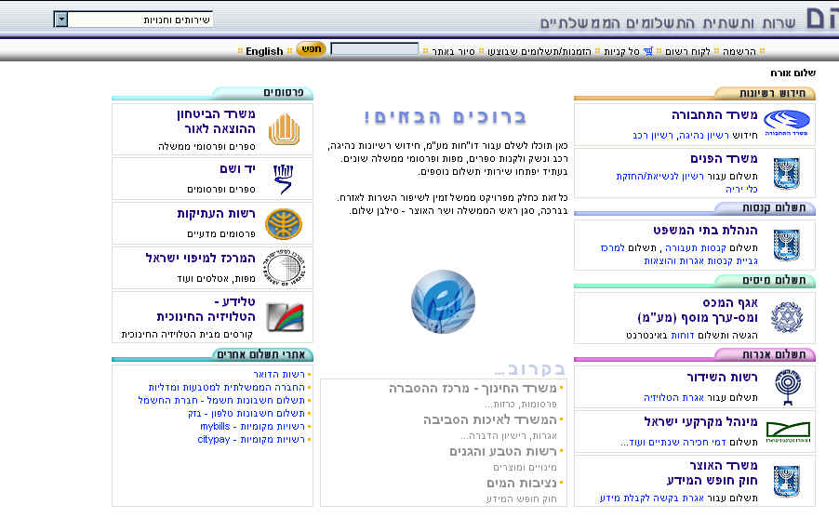

http://ecom.gov.il - Governmental payment service site

Among the virtual stores services are:
- Drivers and vehicle license renewal (Ministry of transportation).
- Weapon license renewal (Ministry of internal affairs).
- Traffic fines payments (Courts administration).
- VAT payments (Ministry of Finance).
- Rental fees (Israeli land administration).
- Freedom of information act fee (Various offices).
- Ministry of defense publications.
- Television and radio fee payments.
- “Yad VaShem” books.
- Maps by the Israeli mapping center.
- Educational television courses.

Many services allow payment by credit as well as direct bank transfer for the citizens’ private bank account (National Bank at this stage).

Increase in government payments server’s usage

Government Gate

The government gate was set up in 1998 to create a single entry point for e-Government services on the Internet. The site was an initiative of the governmental Internet committee at the General accountant office. The site contains access to more that 1000 different services, “yellow pages” of addresses, telephones and e-mail addresses of government workers, information on new governmental services and a concentration of governmental job tenders.

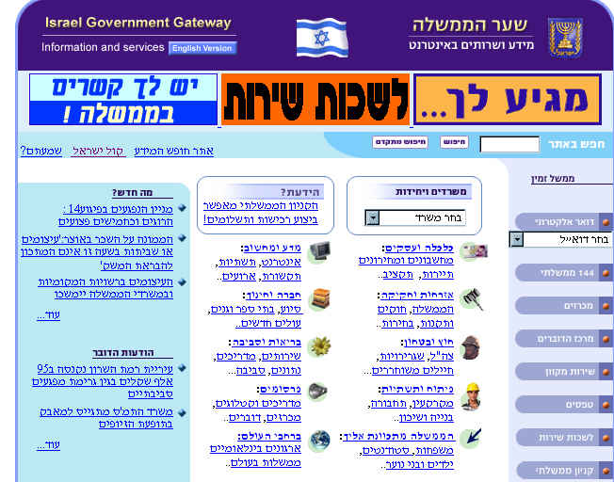

http://www.info.gov.il - Government Gate site

During 2003 the government gate site will go through a major change which will include: complete upgrade of the systems, including new search capabilities, a search engine for all government sites and development of experts portals for target audiences such as: students, immigrants and senior citizens.

Increase in government-gate usage. The orange line indicates the trend

The Safe

The “Safe” project is expected to be launched toward the beginning of 2003. The purpose of this project is to allow secured transfer of official confirmations and sensitive personal information from the government offices to citizens and businesses. This transfer will become possible through the building of a virtual, central “Safe room”, which will hold a secured “safe” (personal mail box) for every citizen and every business. In addition, each document will be signed with an electronic signature that will confirm its origin.
The system will be built with special emphasis on information security, and will allow each governmental office to transfer sensitive official information to citizens and businesses, without compromising information security.

The system will be built in a way that allows the governmental offices to “push” information into the users’ safes, or following a specific request by the user.

Types of information that can be transferred via this system are:
- Official confirmations, such as: Taxes forms, business licenses etc.
- Matriculation certificates.
- Government workers salary statements.
- Army mobilization orders.
- Sensitive, personal information such as status of income task/ national security accounts and more.

Government Forms Service

The forms-site concentrates all the different offices’ forms and allows filling and on-line transfer of the form to the designated office. This makes citizens’ life easier when dealing with the bureaucratic system and in long waits for service in the various offices. It is also easier for the system to provide efficient and rapid service to the citizen.

The server will go on-air for a pilot period towards the end of 2002. In the pilot period the site will hold the Ministry of internal affairs’ forms, aiming to hold all government offices’ forms during 2003.
In parallel, a development is in process to allow transfer of approved forms to the citizen’s secured e-mail box (the “Safe” project).

The forms server will support advanced technologies of electronic signature, thus bringing real progress to all matters concerning citizen’s confirmation and identification by the authorities. Form, that will be electronically signed by governmental offices and sent to the citizen, will be valid for any purpose, as will the citizen’s electronic signature on forms sent to the government offices.

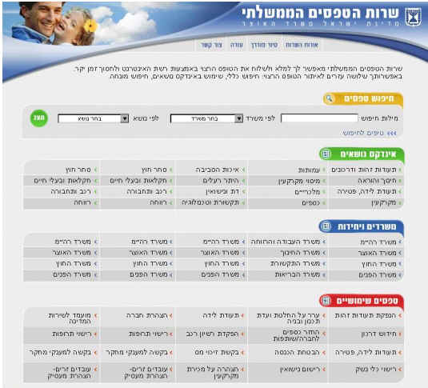

http://www.tofes.gov.il - Forms server’s site

LAYER 5 – SUPPORT AND ASSIMILATION

“Lehava” Project

The information revolution is a result of the technological development that allowed men to store information, sort it, analyze it and pass it around quickly and without effort.
The digital gap is the one between those who adapt the information revolution that brought wealth and happiness, to those who stayed behind, perceiving it to be a negative factor.
The vision of the “Lehava” project is to lessen the digital gap in Israeli society.

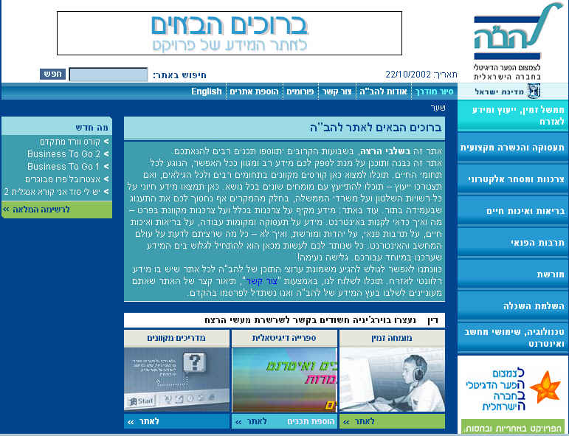

The “Lehava” project site used by students in “Lehava” centers

Objectives
- Assimilation of technology, specifically information technology.
- Improve capabilities of populations that do not have access to technology, to be part of the information age.
- Providing access to all citizens to Hebrew culture treasures.
- To advance education, welfare and leisure-time quality.
- Increase economic productivity and national product through investment in human capital.

Objectives of the project by the end of 2002
- Set-up 100 local centers (or alternate existing ones) during 3 years, with 40 Internet connected workstations in each of them.
- Provide basic knowledge to 500 citizens in each center, enabling them to operate the computer and to search the Internet for relevant information.
- Give citizens with no home computers, the option to use the public computers regularly, for a few hours a week.
- Establish on-line experts counseling-channels to make e-Government and other public services more efficient.
- Provide expertise of information-usage to citizens that may contribute to their education and welfare.

SUMMARY

The developing e-Government vision will entirely change the way of communication between the citizen and the government offices. The first birds can be seen even today, and have already brought significant change, that will undoubtedly become more apparent in the next few years.
The five layers model introduced in this paper, is the one upon which the e-Government vision is based on.

Even today there are large numbers of projects and initiatives that interconnect with the various layers of the model, among which:
- Hebrew translation of the “computerized office” software that was written in open code to allow use by all Israeli citizens.
- Providing e-Government services in mobile technologies such as WAP and SMS.
- Information portal for young people introducing their citizen’s rights and offering usage options of e-Government applications.
- An all-government GIS system presenting locations and directions to governmental offices, demographic information and more.
- Government forms server – to locate all the existing forms in the network , allowing on-line filling and forwarding using digital signature.

The main work in this area is lead by the General accountant’s Information systems unit, but it is done with full cooperation from the rest of the government offices, that contribute and participate in the various steering committees, advancing the project.

In spite of the difficult times that Israel is facing today, the Israeli government does not slow down the entrepreneurial pace. While painfully dealing with the problems of the hour, the government continues to seek progress and prepare for the future.

The e-Government project presents the government and the citizens of Israel with one of the most advanced computer systems infrastructures in the world, in order to create, in a short period of time, a swing of communication, social and economical progress.

The government of Israel has decided on May 12 2002, to make the e-Government project a reality. We believe that e-Government infrastructure is the basis for a better tomorrow, and that our tomorrow is already here!
IBLIOGRAPHY

References

¹ Israeli Knesset, Economy committee, sub committee to information technology, in cooperation with the national committee for infrastructure and information development, “Preparing the state of Israel for the information age” a summary report of mission teams work (May 1997)

2 Deloitte Research, "The Transformation Is Now, Michigan’s Innovative Formula For e-Government Success" (2002)
http://www.dc.com/obx/pages.php?Name=viewpdf&reportname=/pdf/e-michigan.pdf

3 United Nations DPEPA (Division of Public Economies and Public Administrative) and ASPA (American Society for Public administration) (May 2002), "Benchmarking E-government: A Global Perspective"
http://www.unpan.org/egovernment2.asp

Additional Resources

- World Market Research Center, Brown University Professor Darrell M. West (September 2001), "Global E-Government Survey"
- International Council for IT in Government Administration (ICA) and the G7 Government On-Line project (G7GOL), Paul Bird, Andy Honeywood & Rainer (September 1997), "Government use of the Internet"
http://www.itpolicy.gov.il/topics_egov/g7e.htm
- The Knesset’s Sub committee for science and technology meeting protocol of the 14.7.2002 http://www.knesset.gov.il/committees/heb/online/protocol.asp?tid=37
- Government decision from 12.5.2002 on set-up of e-Government infrastructure http://wwwitpolicy.gov.il/yediot/e-gov2002.htm
- Information systems unit, General accountant, Ministry of Finance, Irit Hatzranov, Boaz Dolev and David Rashty, “Initiated paper, e-Government plan 2000, Ministry of Finance (September 1999)
- Ministry of Finance, General accountant’s information systems unit’s site http://wwwmof.gov.il/micun
- “Tehila” project’s site http://www.mof.gov.il/tehila
- Governmental information technologies’ site http://www.itpolicy.goc.il
- Freedom of information act, 1998 http://www.knesset.goc.il/laws/special/heb/freedom_info.htm

